DIGITAL TRANSFORMATION
CAPSTONE CHALLENGE
SmartWash Laundry
Ghadah Falah Bani Ali
Choose the genuine transformation, then redesign the pickup-to-delivery journey.
Your mission
Your team is advising a traditional laundry company. Three initiatives are proposed, but only one is suitable as the main digital transformation capstone. Select it, justify it, and build a simple end-to-end solution.

How to Work as a Team
- First, agree on the correct transformation initiative. Do not divide the team before making this decision.
- Then divide ownership across 5W2H, journey, automation, data, AI, and presentation.
- All members should understand the complete solution, not only their own section.
- The prototype can be a working Make.com scenario or a clearly demonstrated process design if tool access is limited.

1. The Three Initiatives
Read all three initiatives before making a decision. A useful digital idea is not automatically a digital transformation.
Initiative A: Scan Paper Receipts
The company will scan all paper receipts and save them as PDF files in folders.
- Receipts become easier to store and search.
- Customer pickup and delivery processes remain unchanged.

Initiative B: Buy Tablets for Employees
Employees receive tablets to access email and view the same manually entered orders.
- Information is more portable.
- Requests, driver assignment, confirmations, and status updates remain manual.

Initiative C: Digital Pickup and Delivery Service (SELECTED)
Customers submit pickup requests digitally. The process generates an order number, assigns a driver, sends updates, tracks status, collects feedback, and analyzes delays.
- Central request capture and validation
- Automated driver assignment and notifications
- Status tracking, feedback, and management reporting

2. Selection Challenge
Selection rule
Select the initiative that changes the customer experience and the end-to-end process, uses technology and data, and creates measurable value. Do not select an idea only because it uses a digital tool.

A genuine digital transformation should meet these criteria:
- Solves a meaningful customer or business problem
- Changes an end-to-end process, not just one isolated task
- Considers people, process, technology, and data
- Creates measurable business or customer value
- Generates useful data for future decisions

Initiative | Classification | Decision | Reason
Initiative A | Digitization | Reject | It only converts paper receipts into digital files. It does not change the customer experience or the end-to-end process.
Initiative B | Digital improvement | Reject | It improves access to information through tablets, but the main processes remain manual and the customer experience is mostly unchanged.
Initiative C | Digital transformation | Select | It redesigns the complete pickup-to-delivery process using technology, automation, and data to improve customer experience and create measurable value.

Team decision: Initiative C (Digital Pickup and Delivery Service)
One-sentence defence: This is a digital transformation because it redesigns the end-to-end customer journey, uses technology and data, automates the process, and creates measurable customer and business value.

3. 5W2H Analysis
Complete the analysis only for the initiative your team selected (Initiative C).
Element | Guiding question | Team response
What | What process will change? What result will the new process deliver? | Digital pickup and delivery service with online requests, order tracking, and notifications.
Why | Why is the change needed? Which problems or opportunities justify it? | To reduce manual work, improve customer experience, and speed up the service.
Who | Who are the customers, employees, partners, managers, and process owners? | Customers, drivers, laundry staff, and the operations manager.
Where | Where does the current process happen, and where will the future process happen? | Pickup from the customer’s location and processing at the laundry branch using a digital platform.
When | When does the process start? When should the pilot run? When are notifications needed? | The process starts when the customer submits a pickup request. The pilot will start in one area before expanding.
How | How will the redesigned process work from request to completion? | Customers submit requests online, the system assigns a driver, sends updates, tracks the order, and collects feedback.
How much | What tools, effort, training, and approximate cost level are required? | Medium cost. It requires a digital platform, employee training, and automation tools.

4. Customer Journey
Build the current journey first, then redesign it. Include at least one “moment of truth”: a stage that strongly influences customer trust or satisfaction.

4A. Current Customer Journey
Stage | Customer action | Customer thought | Emotion | Pain point | Opportunity / improvement
Need | Decides to use the laundry service. | “I need my clothes cleaned.” | Neutral | No easy way to request the service. | Provide an online booking system.
Request | Calls the laundry to request pickup. | “I hope someone answers.” | Uncertain | Manual phone requests take time. | Digital request form.
Confirmation | Waits for confirmation by phone. | “I don’t know when they will come.” | Frustrated | No instant confirmation. | Automatic confirmation message.
Pickup | Waits for the driver to arrive. | “I hope the driver is on time.” | Worried | No tracking or pickup updates. | Real-time driver tracking.
Processing | Waits without any information. | “I don’t know if my order is ready.” | Anxious | No status updates. | Live order status tracking.
Delivery | Receives the laundry. | “I hope nothing is missing.” | Relieved | Delivery delays and poor communication. | Scheduled delivery notifications.
Feedback | Gives feedback only if contacted. | “Nobody asked for my opinion.” | Indifferent | Feedback is rarely collected. | Digital feedback form after delivery.

4B. Improved Customer Journey
Stage | Customer action | Customer thought | Emotion | Pain point | Opportunity / improvement
Need | Opens the SmartWash app to request the service. | “This is fast and convenient.” | Confident | None | 24/7 digital service.
Request | Submits the pickup request online. | “My request was sent successfully.” | Happy | None | Instant order number and confirmation.
Confirmation | Receives automatic confirmation and pickup time. | “Now I know exactly when they will arrive.” | Reassured | None | Automated notifications.
Pickup | Tracks the driver and hands over the laundry. | “The pickup is on time.” | Satisfied | None | Real-time driver tracking.
Processing | Monitors the order status in the app. | “I can check the progress anytime.” | Relaxed | None | Live status updates.
Delivery | Receives the laundry on time. | “Everything arrived as expected.” | Happy | None | Delivery confirmation and notifications.
Feedback | Rates the service through the app. | “My feedback helps improve the service.” | Valued | None | AI analyzes customer feedback for improvements.

Moment of truth selected by the team: Real-time order tracking and delivery updates.

5. Automation / RPA Process
The prototype can use Google Forms, Google Sheets, Make.com, email, or comparable free tools. A minimum of four automated actions is enough; this design includes six.
Step | Trigger / input | Automated action | Tool | Expected result
1 | Customer submits the pickup form. | A new order is created automatically. | Google Forms | Pickup request is received instantly.
2 | New order received. | Order details are saved automatically. | Google Sheets | Order is stored in the database.
3 | Order saved. | Driver is assigned automatically and notified. | Make.com + Email | Driver receives the pickup request.
4 | Driver accepts the order. | Customer receives a confirmation message with Order ID. | Gmail / Email | Customer knows the request is confirmed.
5 | Laundry status changes (Processing → Ready). | Customer receives a status update automatically. | Make.com + Email | Customer is informed in real time.
6 | Order marked as Completed. | Customer receives a feedback form. | Google Forms + Email | Customer submits feedback for service improvement.

Business Rules
At least three IF/THEN rules (the fourth rule links the process to the data analysis in Section 6):
- If a customer submits a pickup request, then an order ID is generated automatically.
- If the assigned driver does not accept the request within 10 minutes, then the system assigns another available driver.
- If the order status changes to Completed, then a feedback form is automatically sent to the customer.
- If an order’s turnaround time exceeds the agreed limit (for example 36 hours), then the operations manager is alerted automatically.

6. Data Analysis
The fictional dataset below was entered into Google Sheets / Excel. No real personal information is included.
Order ID | Date | Area | Service | Driver | Status | Turnaround (hrs) | Rating | Comment
SW-001 | 2026-07-01 | North | Wash & Fold | Omar | Completed | 22 | 5 | Fast pickup and clean clothes.
SW-002 | 2026-07-01 | South | Dry Cleaning | Lina | Completed | 38 | 3 | Delivery was late but quality was good.
SW-003 | 2026-07-02 | Central | Wash & Fold | Omar | Completed | 25 | 4 | Good service and polite driver.
SW-004 | 2026-07-02 | South | Ironing | Lina | Completed | 42 | 2 | I received no update and waited too long.
SW-005 | 2026-07-03 | North | Dry Cleaning | Omar | Completed | 29 | 4 | Good cleaning but pickup confirmation was slow.
SW-006 | 2026-07-03 | Central | Wash & Fold | Sara | Completed | 20 | 5 | Excellent and very quick.
SW-007 | 2026-07-04 | South | Wash & Fold | Lina | Completed | 36 | 3 | Clothes were clean, but delivery was delayed.
SW-008 | 2026-07-04 | North | Ironing | Omar | Cancelled | – | – | Cancelled because pickup time was not confirmed.
SW-009 | 2026-07-05 | Central | Dry Cleaning | Sara | Completed | 24 | 5 | Professional service.
SW-010 | 2026-07-05 | South | Wash & Fold | Lina | Completed | 41 | 2 | One item was missing from the delivery.
SW-011 | 2026-07-06 | North | Wash & Fold | Omar | Completed | 23 | 5 | Everything was smooth.
SW-012 | 2026-07-06 | Central | Ironing | Sara | In Progress | – | – | Waiting for delivery.
SW-013 | 2026-07-07 | South | Dry Cleaning | Lina | Completed | 35 | 3 | The result was good but communication was poor.
SW-014 | 2026-07-07 | North | Wash & Fold | Omar | Completed | 21 | 5 | Very satisfied.
SW-015 | 2026-07-08 | Central | Wash & Fold | Sara | Completed | 26 | 4 | Good overall.
SW-016 | 2026-07-08 | South | Ironing | Lina | Completed | 44 | 2 | The driver arrived much later than promised.
SW-017 | 2026-07-09 | North | Dry Cleaning | Omar | Completed | 27 | 4 | Clean and well packed.
SW-018 | 2026-07-09 | Central | Wash & Fold | Sara | Completed | 19 | 5 | Quick and easy.
SW-019 | 2026-07-10 | South | Wash & Fold | Lina | Open | – | – | Pickup requested.
SW-020 | 2026-07-10 | North | Ironing | Omar | Completed | 30 | 4 | Good service.

KPI Results
No. | KPI question | Answer
1 | How many total requests or orders are in the dataset? | 20 orders (SW-001 to SW-020).
2 | How many are completed, open, delayed, or cancelled? | Completed 17, Open 1, In Progress 1, Cancelled 1. Delayed (by status): 0, because the dataset has no “Delayed” status.
3 | What is the average completion or turnaround time for completed records? | 29.5 hours (502 hours ÷ 17 completed orders).
4 | What is the average customer rating? (blank ratings ignored) | 3.82 out of 5 (65 ÷ 17 rated orders).
5 | Which category or service is requested most frequently? | Wash & Fold: 10 of 20 orders (50%). Dry Cleaning and Ironing have 5 each.
6 | Which area, employee, technician, or driver needs management attention? | Driver Lina / South area. Average turnaround 39.3 hours versus 22.2–25.3 hours for the other drivers, and average rating 2.5 versus 4.4–4.8. All South orders were handled by Lina, so workload and route should be reviewed before judging the driver.

Visualizations
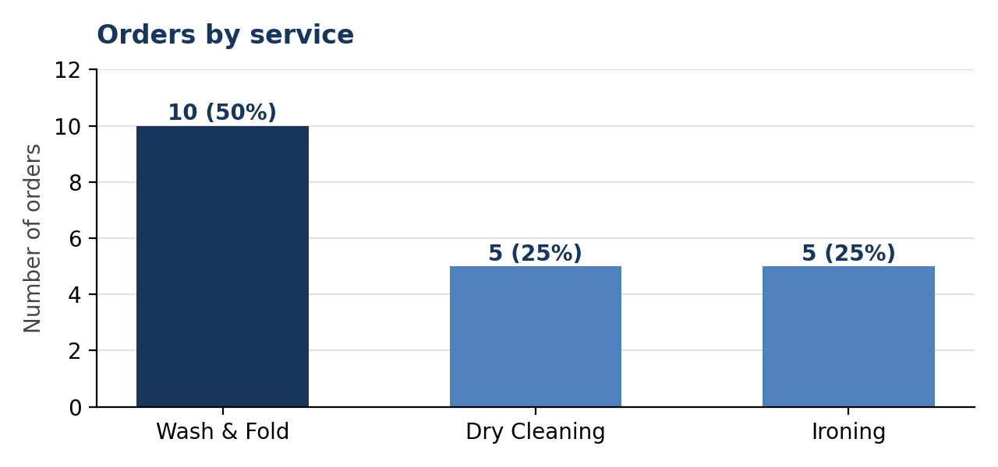
Figure 1: Orders by service. Wash & Fold is half of all demand.
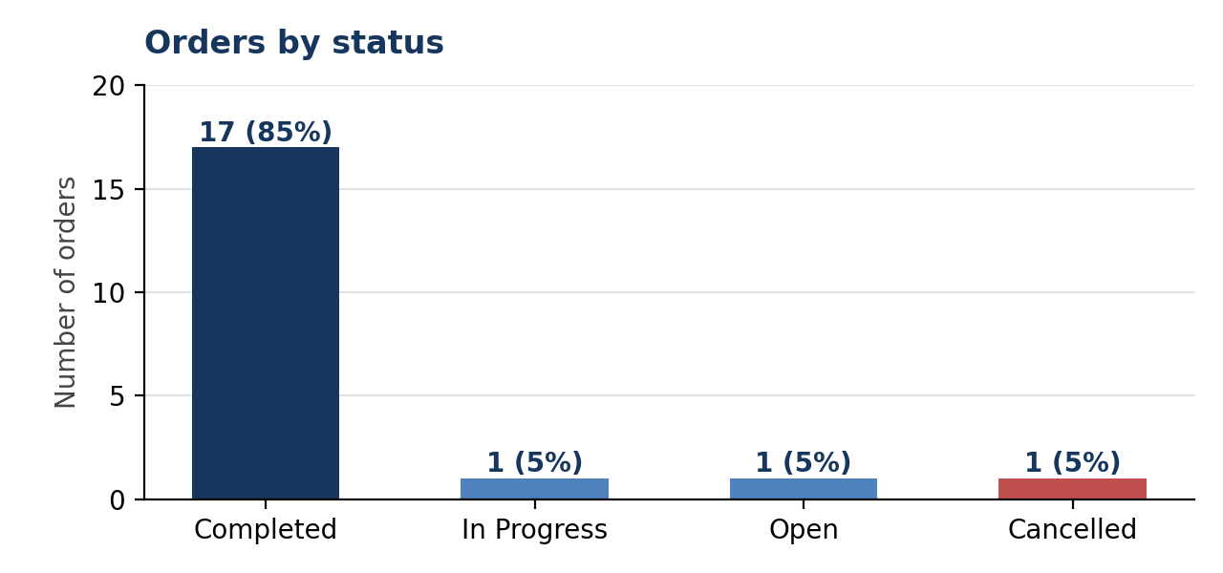
Figure 2: Orders by status. 17 of 20 orders are completed; 3 are not.
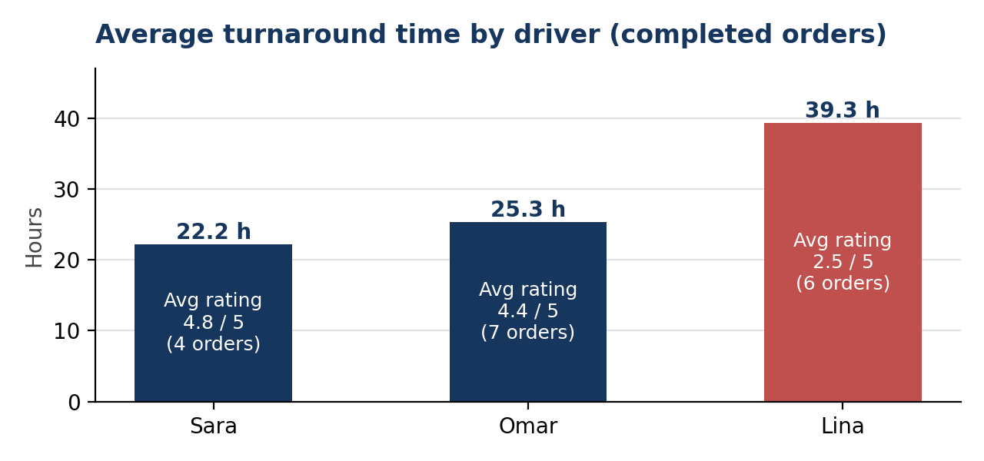
Figure 3: Average turnaround time by driver (completed orders), with average rating.

Business Conclusions
Three conclusions based on the calculations and charts:
- Delivery speed is the main problem, and it is concentrated in the South area. South orders average 39.3 hours versus 25.3 in the North and 22.8 in Central. Every South order took 35 hours or more, and none was rated above 3.
- Wash & Fold is the core service and performs well. It is 50% of orders, averages 25.9 hours, and is rated 4.2. Ironing looks weakest (38.7 hours, rating 2.7), but two of its three completed orders were in the South, so the area is the likely cause rather than the service itself.
- Poor communication loses customers. One order was cancelled because the pickup time was not confirmed, and four comments (SW-004, 005, 008, 013) mention missing updates or slow confirmation. Automatic confirmations and status updates target exactly this cause.

7. AI-Assisted Customer Feedback Analysis
AI is used only to organize and summarize the fictional comments. The team remains responsible for checking the output.
Suggested prompt
You are a customer-experience analyst. For each comment, provide: sentiment (Positive, Neutral, or Negative), category, main issue, urgency (Low, Medium, or High), and a recommended management action. Do not invent facts. Present the result as a table.

No. | Customer comment | Sentiment | Category | Main issue | Urgency | Recommended action
1 | Fast pickup and clean clothes. | Positive | Pickup / Quality | None (strength) | Low | Keep the current pickup standard; use as a positive example.
2 | Delivery was late but quality was good. | Neutral | Delivery | Late delivery | Medium | Send delivery-time alerts and review delivery routes.
3 | Good service and polite driver. | Positive | Staff behaviour | None (strength) | Low | Recognize the driver; share as good practice.
4 | I received no update and waited too long. | Negative | Communication | No status updates | High | Send automatic status updates and contact the customer.
5 | Good cleaning but pickup confirmation was slow. | Neutral | Confirmation | Slow pickup confirmation | Medium | Send an instant automatic confirmation with the pickup time.
6 | Excellent and very quick. | Positive | Speed | None (strength) | Low | Maintain turnaround times.
7 | Clothes were clean, but delivery was delayed. | Neutral | Delivery | Delayed delivery | Medium | Add delay alerts and monitor late orders.
8 | Cancelled because pickup time was not confirmed. | Negative | Confirmation | Pickup time not confirmed; order lost | High | Confirm the pickup slot automatically and follow up to win the customer back.
9 | Professional service. | Positive | Service quality | None (strength) | Low | Maintain service standards.
10 | One item was missing from the delivery. | Negative | Order accuracy | Missing item | High | Add an item checklist at pickup and delivery; resolve the case with the customer.

After using AI, the team checked each classification against the wording of the comment. Comments that mention both a positive and a negative point (2, 5 and 7) were classified as Neutral because only three sentiment levels are allowed.

Team summary of the three most important feedback themes
- Delivery delays reduce customer satisfaction.
- Customers need better communication and regular status updates.
- Fast service and professional staff increase customer satisfaction.

8. Final Recommendations and Presentation
Three recommendations, each supported by the journey, process, data, or AI analysis.
No. | Recommendation | Evidence
1 | Launch automatic confirmation and status notifications (order ID, pickup time, driver on the way, ready, delivered). | Journey: the current journey shows frustration and worry at every waiting stage. Data: SW-008 was cancelled because pickup time was not confirmed, and four comments mention missing updates. AI: the confirmation and communication problems (comments 4 and 8) were both classified High urgency.
2 | Pilot delivery-delay monitoring in the South area: alert the manager when turnaround passes the limit, and review driver workload and routes there. | Data: South averages 39.3 hours versus 22.8–25.3 elsewhere, and its average rating is 2.5 versus 4.5–4.6. Every South order took 35 hours or more. All South orders were handled by one driver, so workload should be checked first.
3 | Close the quality loop: add an item checklist at pickup and delivery, send the feedback form automatically, and review feedback monthly with AI. | AI: “One item was missing from the delivery” was classified High urgency. Process: feedback is rarely collected today, and the new process sends the form automatically after completion.

Expected benefits and success measure
- Benefits: fewer cancellations, faster and more predictable delivery, better ratings, and data for management decisions.
- Success measure (proposed target): reduce average turnaround from 29.5 hours and raise the average rating from 3.82 towards 4.5, measured on the same dataset after the pilot.

Presentation Structure
- Slide 1: The three initiatives and your selection decision
- Slide 2: The business problem and completed 5W2H
- Slide 3: Current customer journey and pain points
- Slide 4: Improved journey and automation process
- Slide 5: KPIs, charts, and AI feedback findings
- Slide 6: Recommendations, expected benefits, and one success measure

Evaluation Rubric
Area | Marks
Selection and justification | 15
5W2H | 15
Customer journey | 20
Automation / RPA design | 20
Data analysis | 15
AI feedback analysis | 10
Presentation | 5
Total | 100

